
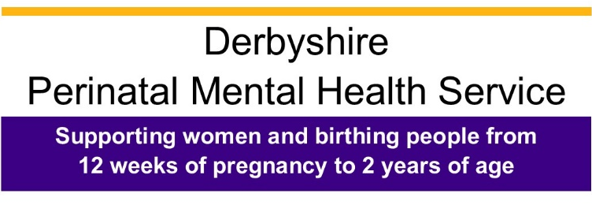
INFORMATION FOR REFERERS
The Perinatal Community Mental Health Service offers specialised care and treatment to women and birthing people experiencing moderate to severe and complex mental health difficulties during pregnancy and the postnatal period. We can take referrals for periconceptional counselling, antenatally from 12 weeks of pregnancy and postnatally up to 24 months. For those referred close to the 24 month period the service will only be able to offer an assessment and signposting to other relevant services. The team offers assessment and treatment of their mental illness whilst ensuring the developing relationship with the baby or processing the loss of a pregnancy / baby.
Further information on Derbyshire Perinatal Mental Health Service and guidance on making referral can be found within the Referral Pathway for Professionals.
Please fill out all the details on the form and once completed email to dhcft.perinatalcmht@nhs.net
RED FLAGS – URGENT REFERRAL REQUIRED
All urgent referrals must be discussed with the perinatal duty worker on the Perinatal adviceline 0300 123 7596
Please note urgent referrals cannot be accepted without this discussion.

PERINATAL RED FLAGS
As you are filling in the current concerns/ reason for referral, please consider the following perinatal red flags and if any of these are present, please ensure they are included.
- Recent significant change in mental state or emergence of new symptoms

- New thoughts or acts of violent self-harm

- New or persistent expression of incompetency
as a mother or estrangement from infant

Please select the reason(s) for referral
Community Perinatal Mental Health Service

☐ Pre-conception counselling for those with existing serious mental illness

☐ Women & birthing people who have developed significant mental health difficulties.
after the first trimester in pregnancy or following delivery that cannot be managed in
primary care

☐ Diagnosis of serious mental illness such as bipolar affective disorder, schizophrenia,
severe depression, or anxiety disorder

☐ Previously under the care of perinatal mental health services

☐ Previous admission to a psychiatric unit

☐ First degree relative with bipolar disorder or serious postnatal illness
(Mother, Father, Siblings)

☐ Significant disorders of bonding and attachment

☐ PTSD symptoms following loss or birth trauma (from 4 weeks post birth)

_______________________________________________________________________

Maternal Mental Health Service

☐ Loss of pregnancy due to miscarriage or termination (from 4 weeks post loss)

☐ Stillbirth (from 4 weeks post loss)

☐ Loss of baby within 28 days following birth or following admission to neonatal unit

☐ Primary or secondary Tokophobia

If you are unsure as to whether your referral meets the criteria, please contact our
advice line Monday to Friday 9.30am – 5pm on 0300 123 7596 to discuss.

PERINATAL COMMUNITY MENTAL HEALTH SERVICE REFERRAL FORM

(If all details are not completed it will delay the referral process)

DATE OF REFERRAL: PATIENT CONSENT OBTAINED: Yes ☐ No ☐
Routine ☐ Urgent ☐ All urgent referrals must be discussed with the perinatal duty worker on the Perinatal adviceline 0300 123 7596 Please note urgent referrals cannot be accepted without this discussion.:
Following discussion with the duty worker and receipt of referral form, referrals that require an urgent assessment will be assessed with 7 calendar days - we aim to offer routine assessments within 4 weeks.
Date of discussion with duty worker:
PATIENT DETAILS
Title: Miss ☐ Mrs ☐ Ms. ☐ Mx. ☐ Another title or none is used (please specify) ☐

First name / preferred name (if applicable):
Surname:
NHS number:
Address & postcode:

Date of birth:
Telephone:
Ethnicity:
Preferred language:
Interpreter needed: Yes ☐ No ☐
If pregnant

EDD:

Place of booking for delivery:

Date of loss if applicable:

REFERRER DETAILS |  | GP’S DETAILS
Name:  Job title: |  | Name:
Address and postcode: |  | Address and postcode:
Phone number:  Email: |  | Phone number:
CHILDREN’S DETAILS
Name | Date of  birth | Gender | Who does the child reside with
Does the patient have parental responsibility? Yes ☐ No ☐
(If antenatal is it assumed patient will have parental responsibility?)

If no, who has parental responsibility?

Any past or current safeguarding concerns? Yes ☐ No ☐

Has a referral to Children’s Services been made? Yes ☐ No ☐

(If yes, please give details of the Team referred to and the date referral was made)

Is there a Child Protection Plan/Child in Need plan in place? Yes ☐ No ☐

If there is a Child Protection Plan, Working Agreement or Court Directive please give details including what category the child(ren) is/are registered under and attach a copy of the document if possible.

CURRENT CONCERNS / REASON FOR REFERRAL
(To include relationship with infant or expected baby/level of functioning with regards to infant
care or degree of distress and level of functioning following loss / trauma)

CURRENT AND PAST PSYCHIATRIC HISTORY
(Including risk to self/others)
OBSTETRIC HISTORY
(Please include information on live births as well as previous loss: miscarriage/medical termination, stillbirth, neonatal loss, birth trauma, Tokophobia, and fertility treatment)
MEDICAL HISTORY
(Please include past and current history)
CURRENT MEDICATION
(Please list ALL medication, including those for physical health and date commenced)

