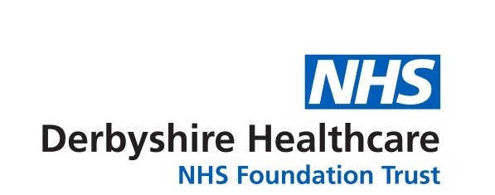

Entry Form
Art competition for people in Derbyshire:
‘A ray of hope’
Age (if under 18):
Name:
Title of entry:
Address (including postcode):

Email:

Telephone no:

Age category: under 18 years 18 years and over (including adults)

Are you a: service user carer Trust member staff governor

volunteer other (please specify)

I understand that by entering this competition I give consent to Derbyshire Healthcare to use my name and/or entry in any publicity material and that it will be attributed to me unless I ask to remain anonymous. I understand that the copyright of the entry will remain with me.

By signing this form, I am confirming that the entry is my original work, that I am the artist and that I am 18 years of age.

Date:
Signature:
The artist is under 18 years of age. I give my consent as parent/guardian:

(Name):
(Signature):
Please tick this box if you do not want your name to be used and wish to remain anonymous.

For guidance on how to enter, please see overleaf.
The closing date is midnight Sunday 9 August 2026.

About your personal information…
Any personal information you share will be used solely for processing your entry to the Trust’s art competition. All applications will be held securely by Derbyshire Healthcare and we will never share or publish your information without your consent. We take your privacy seriously and promise never to sell your data.

Art competition for the people of Derbyshire:
‘A ray of hope’

- The competition is organised by Derbyshire Healthcare NHS Foundation Trust. It has been organised to coincide with the Trust’s Annual Members Meeting, which is taking place virtually on 30 September 2026.
- Entry to this competition is open to people who live in Derby and Derbyshire who are not professional artists (i.e. who exhibit and sell their work).
- The Trust, along with the Council of Governors, is inviting people to share what hope looks like. We are keen to showcase your creativity and celebrate your achievements.
- Entry will be in two age categories – up to and including 17 years; and 18 years and over.
- If you are interested in exploring your creative side and improving your wellbeing then email a clear image of your entry; it must be attached rather than embedded in the email. The competition aims to offer people the opportunity to express themselves and create meaningful artwork to share with others.
- You must complete the entry form and email it with your entry and a short paragraph (up to 200 words) explaining how art helps with your wellbeing, and what hope means to you. If you are shortlisted this will be included with your artwork. If you are under 18 years of age, your parent or guardian must sign the entry form – this is really important.
- Your submission, along with the entry form, can be emailed to dhcft.membership@nhs.net or posted to Denise Baxendale (Membership and Involvement Manager), Derbyshire Healthcare NHS Foundation Trust, c/o Executive Directors’ Suite, Ashbourne Centre, Kingsway Hospital, Kingsway, Derby, DE22 3LZ. We would prefer to receive entries electronically. Entries received in the post cannot be returned, so please make a copy of your entry before you submit it.
- After the closing date of 9 August, a panel of judges will shortlist the entries. The judges’ decision will be final. Finalists will be invited to attend the Trust’s Annual Members Meeting on 30 September where the winners will be announced – see point 9 below.
- The winners will be announced at the Trust’s Annual Members’ Meeting (AMM) on Wednesday 30 September. The meeting will take place virtually (via MS Teams) in the afternoon from 6pm-8pm. We will contact the finalists in advance of the meeting and invite them to attend, and we will do our best to support the finalists to join the meeting. However, we cannot unfortunately provide any IT equipment for this purpose.
- Prizes (artist materials) and certificate will be posted after 1 October.
- The shortlisted entries will be promoted by the Trust – e.g. on the Trust’s website, Facebook page, Trust communications and displayed in our facilities.
- By entering the competition, you keep your copyright but you give permission to Derbyshire Healthcare NHS Foundation Trust to publish your entry and your name on the Trust’s internet and website (including social media). Winning entries may also be displayed in Trust premises.
- If you would like to find out more, please email dhcft.membership@nhs.net or telephone 01332 623723.

