Public Engagement
Changes to Inpatient Rehabilitation Services

Proposed service change of:
Audrey House, Kingsway
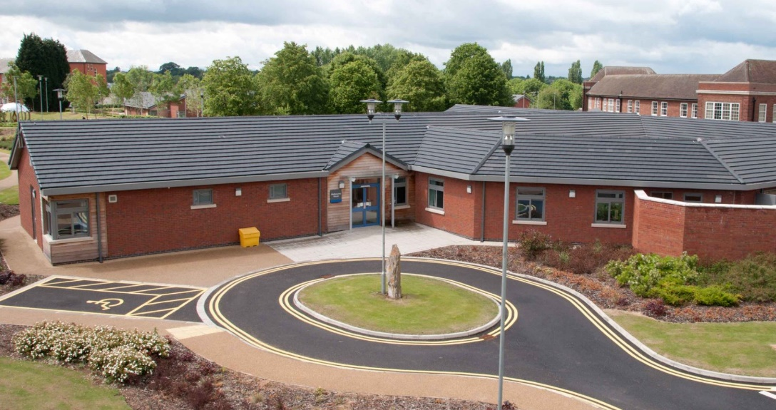
Image of Audrey House and the grounds of Kingsway Hospital

Date of engagement: 24 January 2022 – 7 March 2022

Changes to inpatient rehabilitation services
Derbyshire Healthcare NHS Foundation Trust has been providing mental health rehabilitation services at two units called Cherry Tree Close and Audrey House, which are close to each other at Kingsway Hospital site in Derby.
The services support people from across Derbyshire, providing rehabilitation support for those who have been referred from other hospital settings and the community. The aim is to support people to live outside hospital and reach their full potential within a community setting.
Cherry Tree Close offers 23 beds, provided through five single sex, self-contained bungalows for either four or five service users. There are ten beds at Audrey House.
Over recent years there has been a decrease in demand for inpatient mental health rehabilitation services. Prior to the COVID-19 pandemic, the rehabilitation services had commenced a project to deliver a new community rehabilitation model, however in response to the pandemic Audrey House was temporarily closed in April 2020, with inpatient services being delivered from Cherry Tree Close.
Since April 2020 Cherry Tree Close has been able to manage flow, in to and out of the unit. Bed availability has been regularly monitored, remains stable and there is no expectation that we will need the beds provided at Audrey House for inpatient rehabilitation services in the future. The Trust would therefore like to use Audrey House to support the wider estate needs of the Trust.
We know that many people who receive support from the Trust’s rehabilitation services would benefit from receiving increased support within a community setting. In many cases this would reduce the need for an inpatient stay. Evidence from other areas that have community based rehabilitation services also suggest that community based support provides a better patient experience, improved medicines compliance and reduced need for wider hospital admissions. We hope to commence a community rehabilitation service in 2023. Colleagues who previously worked at Audrey House are temporarily working in other services and it is likely that these colleagues will support the new community service when it is in place.
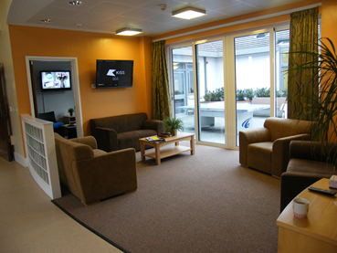
What will Audrey House be used for?
Alongside the new acute mental health development at Kingsway Hospital, the Trust is asking for additional funding from the Joined Up Care Derbyshire system to develop a new eight bed ‘acute plus’ facility for women and a new Psychiatric Intensive Care Unit (PICU) for 14 men. Both of these facilities would also be based at Kingsway Hospital. We will also refurbish the existing Radbourne Unit to continue to provide acute mental health care for female patients, across two wards with single en-suite bedrooms.
This development will need a staged move of existing services, to allow for the development work to take place. We are therefore proposing that Audrey House will initially be used as an interim facility, supporting patients from existing services (such as the Radbourne Unit) while the current ward environments are improved.
When the new acute unit opens in 2024, it is proposed that Audrey House will become the permanent base for the ‘acute plus' facility, providing enhanced support to women, across eight inpatient beds.
We are committed to engaging on this proposed change and are seeking the views of those currently accessing the services, their family and carers and those with a lived experience of mental health services.
We will be engaging with members of the public about these proposals for six weeks between 24 January 2022 – 7 March 2022. This will also include opportunities for our patients and carers to share their views on the proposals.
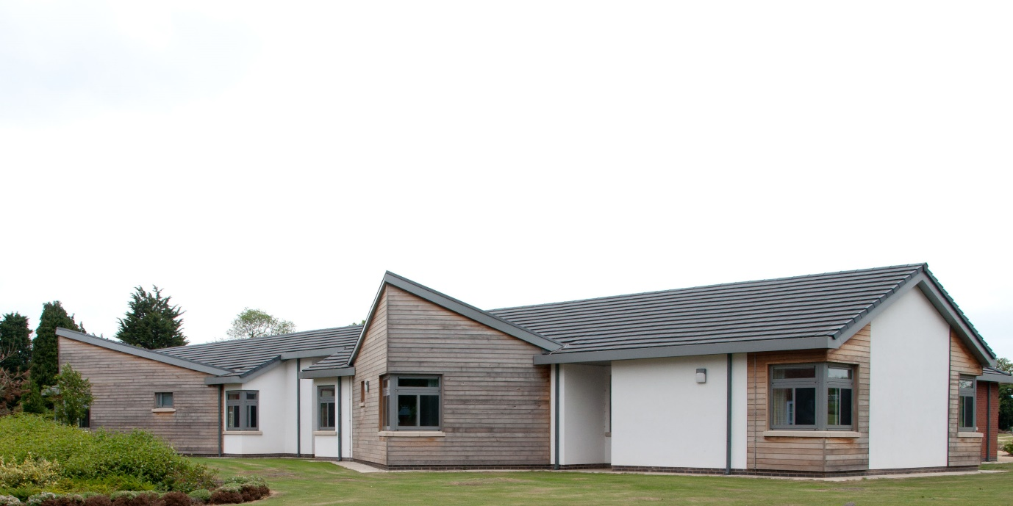
To share your views please:
Click here to complete the survey or enter the following URL into your web browser: https://www.surveymonkey.co.uk/r/ChangesToInpatientRehabilitationServices2022
Attend a meeting: We will be holding two open meetings for people to attend and talk about these proposals on the following dates:
9 February 2022 – 11.30 – 12.30
21 February 2022 – 10am – 11am
If you would like to attend, have any questions or would like to provide feedback in another way, then please contact:
Claire Haynes
Involvement Manager, NHS Derby and Derbyshire CCG

Email: Claire.haynes2@nhs.net

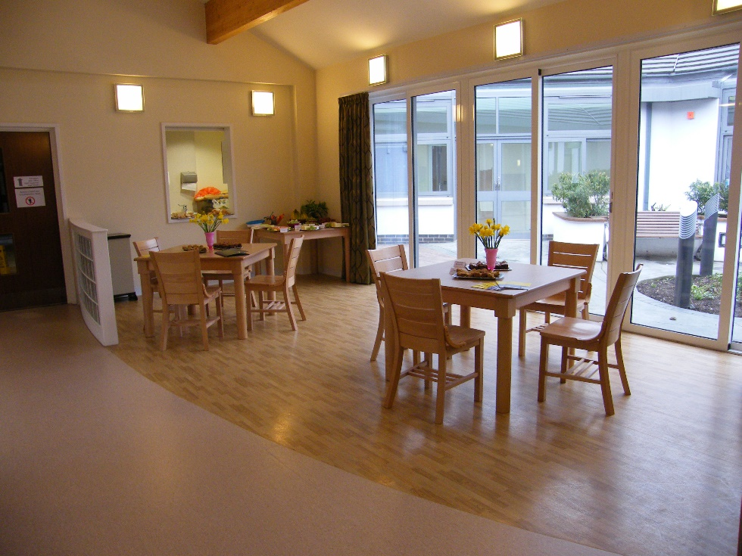

Questionnaire
- Have you or someone you know accessed rehabilitation at Cherry Tree Close or Audrey House?
Yes No
- Do you have any feedback on services provided at Cherry Tree Close or Audrey House?

- Do you understand that the services that were being delivered from Audrey House are now being delivered from Cherry Tree Close with room to accommodate more people as this service is not at full capacity?
Yes No

- Do you understand that the proposal is to move existing services into Audrey house to support the development of other services?
Yes No

- Do you have any comments on the proposals for Audrey House?

Thank you for taking the time to complete this questionnaire.

Equality Monitoring Form (strictly confidential)

NHS Derby and Derbyshire Clinical Commissioning Group recognises and actively promote the benefits of diversity and is committed to treating everyone with dignity and respect regardless of age, disability, gender reassignment, marriage and civil partnership, pregnancy and maternity, race, religion or belief, sex (gender) or sexual orientation. To ensure that we understand who has given us feedback we would like you to complete the short monitoring section below in relation to yourself or if you are representing another person in relation to them. The information provided will only be used for the purpose it has been collected for and will not be passed on to any third parties.

Our Commitment to Data Privacy and Confidentiality Issues
We are committed to protecting your privacy and will only process data in accordance with the Data Protection Legislation. This includes the General Data Protection Regulation (EU) 2016/679 (GDPR), the Data Protection Act (DPA) 2018, the Law Enforcement Directive (Directive (EU) 2016/680) (LED) and any applicable national Laws implementing them as amended from time to time.
In addition, consideration will also be given to all applicable Law concerning privacy, confidentiality, the processing and sharing of personal data including the Human Rights Act 1998, the Health and Social Care Act 2012 as amended by the Health and Social Care (Safety and Quality) Act 2015, the common law duty of confidentiality and the Privacy and Electronic Communications (EC Directive) Regulations.

Please (X) the relevant box under each equality characteristic

What is your Postcode? The first four letters/numbers of your postcode will help us understand where services may need to be directed (we will not be able to identify your address from this)
First part of Post Code e.g. LE1 2 |  |  |  |  | I’d prefer not to say

What is your Date of Birth?
Please complete your date of birth: | M | M | Y | Y | Y | Y | I’d prefer not to say

Please choose one option that best describes your relationship status:
Single |  | In a relationship |  | Living with partner
Married/  Civil Partnership |  | Separated |  | Divorced/ Dissolved Civil Partnership
Widowed/Surviving Civil Partner |  | Other |  | I’d prefer not to say
Child

What is your Gender/Sex?
Male |  | Female |  | Transgender male
Transgender female |  | Non-binary (including agender, genderfluid and genderqueer) |  | Prefer to self-describe as… (please specify)
Prefer not to say

What is your sexual orientation?
Straight Prefer not to say Prefer to self-describe as… (please specify) |  | Gay woman / Lesbian |  | Gay man
Bisexual |  | Pansexual |  | Asexual
Prefer not to say |  | Prefer to self-describe as… (please specify)

Are your day-to-day activities limited because of a health condition or illness which has lasted, or is expected to last, at least 12 months? (Please select all that apply)
Vision (such as due to blindness or partial sight)
Hearing (such as due to deafness or partial hearing)
Mobility (such as difficulty walking short distances, climbing stairs)
Dexterity (such as lifting and carrying objects, using a keyboard)
Ability to concentrate, learn or understand (Learning Disability/Difficulty)
Memory
Mental ill-health
Stamina or breathing difficulty or fatigue
Social or behavioural issues (for example, due to neuro diverse conditions such as Autism, Attention Deficit Disorder or Aspergers’ Syndrome)
No
I’d prefer not to say
Any other condition or illness, please describe:

Do you look after, or give any help or support to family members, friends, neighbours or others because of either:
Long-term physical or mental-ill-health/disability |  | Problems related to old age |  | No
I’d prefer not to say |  | Other, please describe:

Please choose one option that best describes your Ethnic Group or Background?
White
English/Welsh/Scottish/Northern Irish/British
Irish
Gypsy or Irish Traveller
Any other White background, please describe:
Mixed/multiple ethnic groups
White and Black Caribbean
White and Black African
White and Asian
Any other mixed/multiple ethnic background, please describe:

Asian/Asian British
Indian
Pakistani
Bangladeshi
Any other Asian background, please describe:
Black/African/Caribbean/Black British
African
Caribbean
Any other Black/African/Caribbean background, please describe:
Chinese
Chinese
Other ethnic group
Arab
Any other ethnic group, please describe:
I’d prefer not to say

Please choose one option that best describes your religious identity?
No religion |  | Christian (including Church of England, Catholic, Protestant and all other Christian denominations)
Buddhist |  | Hindu |  | Jewish
Muslim |  | Sikh |  | Baha'i
Jain |  | I’d prefer not to say
Any other religion, please describe:

Please choose your preferred language option for communicating and interpreting information
English |  | Arabic |  | Bengali
BSL (British Sign Language) |  | Chinese |  | Farsi
Gujarati |  | Hindi |  | Pashtu
Polish |  | Portuguese |  | Punjabi
Slovak |  | Somali |  | Turkish
Urdu
Any other preferred language, please describe:

For any questions or feedback regarding this form please contact Claire Haynes, Involvement Manager either by Phone: 01332 868677or Email: claire.haynes2@nhs.net
All NHS Derby and Derbyshire Clinical Commissioning Group documents can be provided in large print or Braille formats, if requested and an interpreting service is available to individuals who require them.
If you need help accessing this document, please contact our Patient Advice and Liaise Service (PALS) on: 0800 032 32 35 or email: ddccg.enquiries@nhs.net

Aby otrzymać pomoc w dostępie do niniejszego dokumentu, prosimy o kontakt z działem ds. porad i kontaktów z pacjentami [Patient Advice and Liaison Service – PALS] pod numerem telefonu: 0800 032 32 35 lub pod adresem e-mail: ddccg.enquiries@nhs.net
ਜੇ ਤੁਹਾਨੂੰ ਇਸ ਦਸਤਾਵੇਜ਼ ਤੱਕ ਪਹੁੰਚ ਕਰਨ ਲਈ ਮਦਦ ਦੀ ਲੋੜ ਹੈ ਤਾਂ ਕਿਰਪਾ ਕਰਕੇ ਸਾਡੀ ਪੇਸ਼ੇਂਟ ਐਡਵਾਇਜ਼ ਅਤੇ ਲਿਏਜ਼ ਸਰਵਿਸ (ਮਰੀਜ਼ ਲਈ ਸਲਾਹ ਅਤੇ ਸੰਪਰਕ ਸੇਵਾ) (PALS) ਨੂੰ ਇੱਥੇ ਫੋਨ ਕਰੋ: 0800 032 32 35 ਜਾਂ ਇੱਥੇ ਈਮੇਲ ਕਰੋ: ddccg.enquiries@nhs.net
Ak potrebujete pomoc s prístupom k tomuto dokumentu, prosím, kontaktujte našu Službu pre poradenstvo a spoluprácu s pacientom (PALS) telefonicky na: 0800 032 32 35 alebo e-mailom na: ddccg.enquiries@nhs.net
اگر آپکو اس دستاویز تک رسائی میں مدد چاہئے تو براۓ مہربانی ہماری مریضوں کے لیے مشاورتی اور باہمی تعلقاتی سروس (پالز) سے0800 032 32 35 پر ای میل کریں پر رابطہ کریں یا ddccg.enquiries@nhs.net

