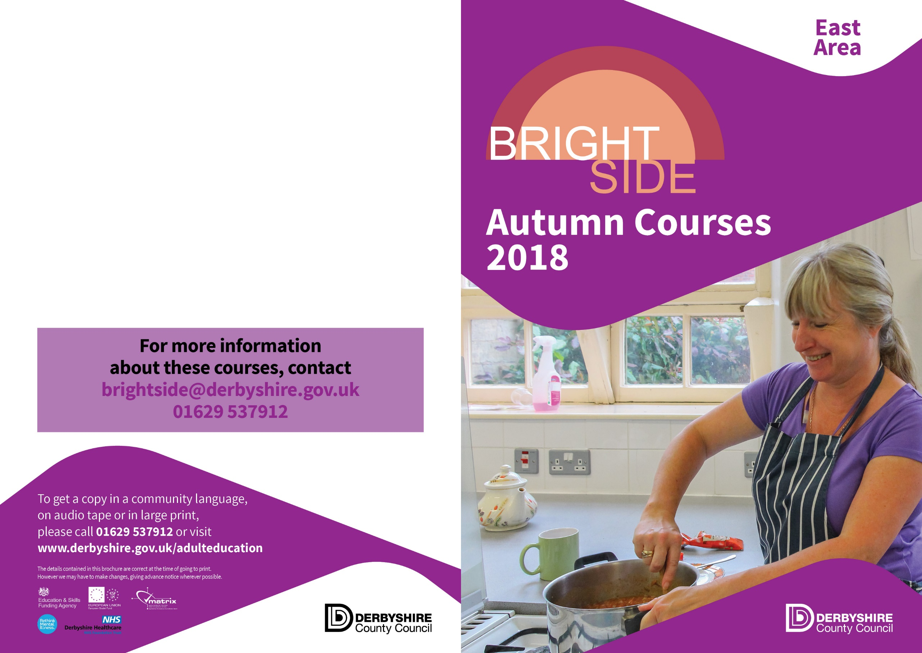
These FREE courses are available for anyone experiencing mental health difficulties, or emotional or psychological distress. One in four of us go through this at some time in our lives. People can join Bright Side as an individual or through a support group.

The Bright Side courses are normally 12 hours long, spread over several weeks. They deliver a rich variety of practical and hands on skills, such as outdoor and creative activities, cookery and relaxation, all in a friendly setting.

Each programme will be adapted to the interests of each group and can offer a stepping stone onto other activities.

People with understanding and experience of mental health issues have helped us to develop Bright Side courses because they know how learning new skills can help. Additional support will be provided to help people to join in, enjoy themselves and move on.


Bright Side in Bolsover…

Healthy Takeaways
Day | Time | Start Date | Venue
Friday | 09:30-11:30 | 14th September | Bolsover

Book Folding and Paper Crafts
Day | Time | Start Date | Venue
Wednesday | 12:30-14:30 | 12th September | Bolsover

Jewellery Making…Upcycling and Recycling
Day | Time | Start Date | Venue
Wednesday | 12:30-14:30 | 7th November | Bolsover

Bolsover Adult Education Centre (01629) 537912
Bolsover.ace@derbyshire.gov.uk

Hunloke…

Art for All
Day | Time | Start Date | Venue
Tuesday | 13:00-15:00 | 11th September | Hunloke

Hunloke Adult Education Centre (01629) 535002
Hunloke.ace@derbyshire.gov.uk

Clay Cross…

Healthy Takeaways
Day | Time | Start Date | Venue
Monday | 10:00-12:00 | 10th September | Clay Cross

Pottery
Day | Time | Start Date | Venue
Friday | 12:30-14:30 | 14th September | Clay Cross

Clay Cross Adult Education Centre (01629) 537108
Claycross.ace@derbyshire.ace.uk

Please call or email centres to book your place

