Experiences of Hospital Admissions

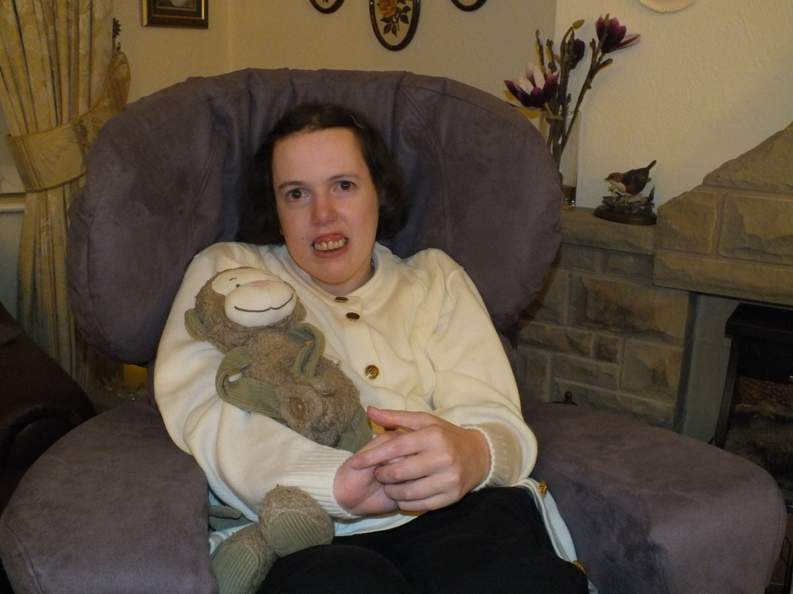

Emma at home relaxing in her comfortable chair

Emma, who has profound and multiple disabilities, will be 35 years old in July. She is a charming and mostly happy young woman but as she is unable to do anything at all for herself, she requires an enormous amount of care around the clock. She has to be fed, given drinks and medication and needs full support with personal care and all aspects of her daily life. She seemed fine at birth but her epilepsy started just before she was three months old. Over the next few years she had frequent and prolonged seizures, many of which were status always requiring medical intervention. We owe a debt of gratitude to the staff at the Derbyshire Children’s Hospital for saving Emma’s life on numerous occasions and also to the Ambulance Service who frequently rushed her to hospital.

Throughout her life her epilepsy has continued to be very troublesome and largely unpredictable and it is still unusual for 24 hours to pass without a seizure but, on the whole, with daily medication, currently Epilim, Lamotrigine and Clobazam, the seizures usually stop within a couple of minutes. However, Emma has been admitted to hospital for prolonged seizures and also on those occasions where she has experienced clusters of fits over several days preventing her from taking fluids.

Many of Emma’s seizures occur in her sleep and she often has periods of wakefulness during the night. Her behaviour can be difficult and she frequently has outbursts of mania/excessive laughing and presents problems with her unwillingness to drink always needing much encouragement here. Feeding is not easy because her severe scoliosis requires her to have specially supported seating to enable her to sit as upright as possible. You will appreciate therefore that caring for Emma at home is not easy but as we have the necessary equipment – moulded wheelchair, an adjustable and supportive armchair, Floorline bed and special showering facilities – we manage fairly well with the day to day tasks. However, caring for Emma when she is in hospital is difficult in the extreme. While she is feeling ill and lying in hospital taking fluids through a drip, her care at this stage is not too difficult. As her condition improves and we need to start giving food and drinks by mouth, then these tasks become impossible for us and for Emma while in a hospital bed! It is therefore important, once the seizures have stopped and a drip is no longer required, for Emma to be allowed to return home to be cared for there.

The main medical problems on admission to hospital have been the many attempts made to obtain a blood sample and to insert a cannula. Her veins are never easy to find and of course this task becomes more difficult when she is to some degree dehydrated. On one very distressing occasion a doctor tried for some considerable time to obtain blood from several areas of her body, finally trying her groin area and causing a temporary haemorrhage. Emma was deeply distressed and badly bruised all over with the many attempts made, but even now he had still been unsuccessful in obtaining the blood sample. An anaesthetist at this point was called who obtained the sample without any difficulty within a couple of minutes! We therefore feel that only the most appropriately trained personnel should take the blood tests to minimise the stress to Emma.

Our last visit to hospital in September 2013 was certainly an improved experience. The nurses showed a willingness to listen and to help when necessary. We have been caring for Emma for nearly 35 years and have been watching symptoms and reading the signs of her condition throughout her life. We are, after all, caring for someone who has no language and who cannot point to any site where there may be pain and who frequently reacts with laughter when something hurts or is troubling her. She often responds in unexpected and odd ways to feeling ill. While we respect the expertise of the doctors and consultants we believe it would be helpful for them to take on board our comments before making their important medical decisions.

Some doctors of course do and have shown great consideration, however there have been others who have caused us upset. For example, a couple of years ago, a doctor requested a catheter for Emma as she had not passed urine for longer than one might expect. I had a word with him and asked if he would please wait as it was not unusual for her to stay dry for long periods. He said to me that would be fine and then immediately proceeded to a nurse and requested a catheter! Where the patient cannot speak for herself, surely respect can be shown to a carer who is at her side each and every day.

We are sure you will understand that we feel it is essential to remain with Emma throughout the day and the night when she is in hospital. For her safety she needs a watchful eye the whole of the time. She cannot give herself food or drink or express any emotional feelings or needs. On her last visit my husband, Colin, stayed with Emma while I returned home briefly to collect a few things. He noticed her arm was swelling as the cannula’s entry had tissued. This is the sort of thing that we feel would not necessarily have been picked up quickly by the medical staff. We appreciate of course that a nurse cannot be spared to sit with Emma all the time.

It is often very difficult for medical staff to carry out the necessary diagnostic tests without our help. For example, on Emma’s last admission to hospital the doctor felt that there was the need for a chest x-ray. The nurse, seeing we were tired, suggested we had a short break while she took her along to radiography. I decided to follow on behind as I thought I might be needed! However the nurse took her into the x-ray unit and from the waiting area I could hear the noise Emma was making! It wasn’t long before the door opened and a request made, “please could you come and help as we are unable to keep her still?” With some singing and gentle coaxing and with me holding Emma securely, the x rays went ahead successfully. Later on, Colin accompanied her for a CT scan to make sure once again that she remained calm and still. At these times, without our presence, conducting such tests would be almost impossible.

Debbie Edwards, the Acute Liaison Nurse for Adults with Learning Disabilities, was a great help to us on our last visit. We really appreciated her help, support and understanding throughout Emma’s short stay. The Hospital Traffic Light Assessment is very useful as it gives a quick indication of the patient’s needs, interests and problems. Debbie also effectively streamlined the discharge process which was so important for us.

We believe the most difficult part of any hospital stay is being there with Emma throughout the night. It is important that someone stays with her and this is not easy when there are no suitable facilities for doing so. Those who staff children’s wards appear to see the need to make it possible for parents to stay with their children and yet it is surely as important, if not more so, for a parent/carer to stay with a very vulnerable adult who has no ability to communicate. The provision of a reclining armchair so that the parent might at least be comfortable through the night and perhaps get some sleep, would be an excellent addition. It would not be significantly expensive and yet it would be an enormous help at this difficult time. Colin and I are both 65 and suffer with back pain as we go about moving and handling on a day to day basis. Having to spend the night on an upright, uncomfortable chair is something we actually dread and so very much hope that consideration will be given to providing a reclining chair in the near future.

It is important that as parents we endeavour to keep healthy so that we can go on with the daily task of caring. Looking after Emma in hospital is incredibly stressful and tiring. We feel that many things had improved on her last admission. We always appreciate the good medical care given to our daughter and also the important support provided by Debbie Edwards. While there have been some distressing moments in hospital, there have also been some nice touches. For example, it was so thoughtful of the doctor who had treated Emma in her status seizure to return the following day, even though he was not working on that ward, to inquire how she was progressing.

We feel that many people do not realise how very limited Emma is and this is understandable if they have never experienced such profound disability. Hopefully, greater awareness of learning disabilities, both mild and severe, will lead to an ever improving service. We also trust that careful consideration will be given to making better the facilities for carers who need to spend extended periods in hospital alongside their loved ones.

We thank you for reading about our experiences at hospital with Emma.

Margaret Richards

April 2014

