Policy and Procedure for Handling Patient Feedback 2022 - 2025:
Comments, Concerns, Complaints, and Compliments

See also: | Located in the following policy folder on the Trust Intranet
Agreement for the Joint Handling of Health and Social Care Complaints | Supporting document
Being Open and Duty of Candour Policy and Procedures | Clinical / Clinical General
Incident Policy and Procedure | Corporate and Risk

NB, The links to leaflets and other documents provided in this Policy are accessible to staff but may not be available to the Public through this Policy where it is listed on the external Trust website. However some can be accessed via the Patient Experience webpage: Patient experience (complaints and PALS) :: Derbyshire Healthcare NHS Foundation Trust (derbyshirehealthcareft.nhs.uk) under “Useful guides and leaflets”.

Service area | Issue date | Issue no. | Review date | 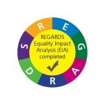
Trust wide | November 2022 | 11 | November 2025
Ratified by | Ratification date | Committee/Group responsible for review:
Quality and Safeguarding Committee | 30 November 2022 | Quality and Safeguarding Committee
 Did you print this document?
Document published on the Trust Intranet under: Corporate and Risk

Please be advised that the Trust discourages retention of hard copies of policies and can only guarantee that the Policy on the Trust Intranet site is the most up-to date version

ACCESSIBLE INFORMATION STANDARD
The Accessible Information Standard directs and defines a specific, consistent approach to identifying, recording, flagging, sharing and meeting the information and communication support needs of service users.

Ensure you have considered an agreed process for: sending out correspondence in alternative formats and appointments for patients / service users with communication needs, where this is applicable.

Checklist for Handling Patient Feedback: Comments, Concerns, Complaints and Compliments

Summary (Plain English) Summarise the main points of the policy below in a style that is clear and easy to understand. Ensure the whole policy is written in plain English, using simple language where possible and avoiding convoluted sentences and obscure words. The resulting policy should be easy to read, understand and use,
This document details the Trusts policy and procedure in response to DH’s regulations 2009 for the handling of complaints.

Name / Title of policy/procedure | Policy and Procedure for Handling Patient Feedback 2022 – 2025. Comments, Concerns, Complaints, and Compliments
Aim of Policy | To ensure that all staff working within Derbyshire Healthcare NHS Foundation Trust (DHCFT) are able to handle complaints in line with the regulations issued by the Department of Health.
Sponsor (Director lead) | Executive Director of Nursing and Patient Experience
Author(s) | Complaints/Patient Experience Manager
Name of policy being replaced | Handling Patient Feedback: Comments, Concerns, Complaints and Compliments Policy and Procedures 2019-2022 | Version No of previous policy:  10

Reason for document production: | Content reviewed and updated.
Commissioning individual or group: | Patient Experience Committee

Individuals or groups who have been consulted: | Date: | Response
Patient Experience Committee | 24/02/2022 | Agreed
Quality and Safeguarding Committee | 30/11/2022 | Ratified

Version control (for minor amendments)
Date | Author | Comment
24/02/2022 | Complaints/Patient Experience Manager | Content reviewed and updated, amendments made.
19/04/2022 | Complaints/Patient Experience Manager | P18. Pictoral Complaints Card, Procedure and workbook: these documents are currently being discussed with Adult Neurodevelopmental Services.

Policy and Procedure for Handling Patient Feedback: Comments, Concerns, Complaints and Compliments

1 Aim 4
2 Purpose 4
3 Requirements 4
4 Background 5
5 Areas for implementation 5
6 Accountability and responsibilities 5
7 Intended users 7
8 Definition of complaint 7
9 Arrangements 7
10 Matters Excluded from the Complaints Process 9
11 Trust procedure - Complaints 10
12. Stage 2: Parliamentary and Health Service Ombudsman (PHS0) 18
13. Trust procedure – Comments 19
14. Trust procedure - Compliments 19
15. Process by which organisation aims to improve 19
16. References and associated documentation 20
Appendices 21
Appendix 1 – Accessible Compliments and Complaints Leaflets and the DHCFT Patient Experience Leaflet 21
Appendix 2 – Patient Experience Flowchart 21
Appendix 3 – Advice for staff involved in a complaint investigation 21
Appendix 4 – Complaints Report and Explanation Templates 22

Policy and Procedure for Handling Patient Feedback: The 4Cs - Comments, Concerns, Complaints and Compliments

1 Aim

To ensure that all staff working within Derbyshire Healthcare NHS Foundation Trust (DHCFT) are able to handle complaints in line with the regulations issued by the Department of Health.

Concerns and complaints provide the Trust with an opportunity to put things right and improve services based on Patient/Family/Carer Experiences. They can also provide constructive ideas for improving services, culture and attitudes.

The Trust’s philosophy for being open and striving to achieve patient and public satisfaction shifts the emphasis from defending the Trust in the face of complaints, to a culture of value and a commitment to continually improve services, to learn and strive to deliver the best care possible. All complaints will be received positively, investigated promptly and responded to sympathetically, with action, where appropriate, to prevent recurrence of the circumstances leading to the complaint.

2 Purpose
The purpose of this policy is to set out the process for making complaints for the benefit of complainants and to ensure that there is a consistent and appropriate approach to the handling of complaints within the Trust. Anyone, regardless of age, gender, disability, race etc. should be able to make a complaint, secure in the knowledge that it will be fully investigated and handled fairly and that they will receive a timely explanation, an apology if appropriate and information about any action taken or planned to improve services as a result of the complaint.

3 Requirements
It is necessary to ensure that the Trust has a policy and procedure in place, in line with national regulations, to handle complaints consistent with its role and functions, in an effective, sensitive and efficient manner.

The Trust is required to have in place arrangements for the handling and consideration of concerns and complaints which ensure that they are dealt with efficiently and investigated properly. Complainants should be treated with respect, dignity and courtesy. Complainants should be assisted in enabling them to understand the procedure and provided with advice on where to obtain independent assistance. Complainant should receive appropriate and proportionate responses within an agreed timeframe. They should be told the outcome of the investigation and any actions taken.

Complainants, their relatives and carers have the right to receive all treatment with dignity and respect and should not, under any circumstances, be discriminated against during or following a complaint. The Patient Experience Team will follow up any reported incident or potential concerns of discrimination by highlighting these concerns with staff and complainants. All such incidents are reported to the Head of Patient Experience/Director of Nursing and Patient Experience.

The complaints procedure is concerned solely with resolving complaints and not with investigating disciplinary matters. It may; however, be that during the investigation of a complaint, information comes to light, which indicates the need for a disciplinary investigation. This is a separate matter for management outside the complaints procedure and must be subject to a separate process of investigation.

Within the regulations a person can pursue a complaint and claim simultaneously.

Confidentiality
Complaint records should be kept separate from health records, subject to the need to record information, which is strictly relevant to the patient's health. Such records must be treated with the same degree of confidentiality as normal medical records and would be open to disclosure in legal proceedings.’

4 Background
National Policy dictates that it is essential where complaints arise within the NHS that they are dealt with sensitively and effectively.

The National Health Service (Complaints) Regulations 2004, as amended in 2006, were revoked in March 2009. Plans to reform NHS and adult social care complaints were formally consulted on between June and October 2007. The Local Authority Social Services and National Health Service Complaints (England) Regulations 2009 came into force on 1st April 2009 and introduced a single complaints system for all health and local authority social services in England. This was a new approach to resolving complaints more effectively by responding more personally and positively to individuals who are unhappy and ensure opportunities for services to learn and improve are not lost. The 2009 complaints regulations replaced the previous three-stage process with a two-stage process: Stage 1 is resolution by Trusts, Stage 2 is undertaken by the Parliamentary and Health Service Commissioner (Ombudsman).

5 Areas for implementation
All areas

6 Accountability and responsibilities

6.1 Derbyshire Healthcare NHS Foundation Trust (DHCFT)
In regards to complaints handling, DHCFT is the overall ‘Responsible Body’ and the Chief Executive is the ‘Responsible Person’ who is responsible for ensuring compliance with the arrangements under the 2009 regulations. Regulation 4(1)

6.2 Derbyshire Healthcare NHS Foundation Trust (DHCFT)
DHCFT Board has overall responsibility for effective complaints management within the organisation and should ensure DHCFT complies with its statutory obligations. The Trust Board has responsibility for ensuring compliance with the arrangements of the NHS Complaints Regulations ‘The Local Authority Social Services and National Health Service Complaints (England) Regulations 2009’.

6.3 Complaints Manager
The 2009 Regulations states that there must be a designated Complaints Manager who is responsible for managing the procedures for handling and considering complaints. The Complaints Manager is responsible for managing the procedures for handling and considering complaints in accordance with the arrangements under the regulations. The Complaints Manager sits within the Patient Experience Team in the Nursing and Quality Directorate.

The Complaints Manager has responsibility for:
- managing the processes in place for collecting, collating, responding to and reporting on the feedback received by the Trust
- the local complaints procedure and compliance of the statutory regulations.
- ensuring implementation of the Complaints policy across the Trust
- the development and maintenance of a robust Trust-wide Complaints Reporting system.
- ensuring that there is a system in place to complete and report on actions taken following complaints investigations
- ensuring that staff are aware of the Ombudsman’s key principles
- Cross agency complaints which are handled in accordance the ‘Agreement for the Joint Handling of Health and Social Care Complaints Derbyshire Wide’
- Ensuring that systems are in place to capture and report on compliments received

The Complaints Manager is expected, when necessary, to work with the Family Liaison Team, the Risk and Incidents Team, Legal Services Department and Operational teams. All complaints should be handled using the Being Open approach taking into account the legal requirements of Duty of Candour.
The Trust expects the Patient Experience Team to be readily accessible to both the public and members of staff. The Patient Experience team should be available to complainants who do not wish to raise their concerns with those directly involved with their care, or where front-line staff are unable to deal with the complaint. The ethos of the Patient Advice and Liaison (PALS) Service is maintained and promoted by the Patient Experience Team.

6.4 All Managers
Managers are responsible for having, within their team, effective systems in place for handling Patient Experience feedback covering comments, concerns, complaints and compliments, ensuring that staff follow the operational systems in place to fulfil the requirements of this policy. This includes ensuring that concerns and complaints are investigated in accordance with this policy.

6.5 All Staff
All staff are responsible for dealing with concerns and complaints as soon as they arise in line with this policy and procedure and for reporting compliments when received.

6.6 Training
Systems Based Analysis Investigation training will be provided in line with the Training Framework, Complaints and Customer Care training will be available through ad hoc sessions. Good practice suggestions for conducting robust investigations are enclosed

7 Intended users
All Derbyshire Healthcare NHS Foundation Trust staff.

8 Definition of complaint
The Citizen’s Charter Complaints Task Force defines a complaint in the NHS as being “an expression of dissatisfaction that requires a response.” In this Trust concerns and complaints are graded to identify the level of investigation required.

9 Arrangements
The regulations cover the fundamental requirements of good complaints handling, not the processes through which outcomes are to be delivered. This enables the Trust to be more flexible in agreeing the best way to achieve a satisfactory outcome with the complainant and providing a more personalised approach. This is supported by the six Principles of the Parliamentary and Health Ombudsman which are:-

- Getting it right
- Being customer focused
- Being open and accountable
- Acting fairly and proportionately
- Putting things right
- Seeking continuous improvement

This Policy applies to complaints made in relation to Derbyshire Healthcare NHS Foundation Trust in respect of the services provided, delivery of its duties and functions, the conduct of its staff and the decisions it makes.

Trust staff are encouraged, in conjunction with their line manager, to deal with concerns along with requests for information to which they can provide an immediate response. Any concern not resolved by the end of the next working day should be dealt with in accordance with this policy.

Complaints may sometimes need to be redirected to another agency within the NHS or to the Local Authority and may require multi-agency investigations. The Complaints Manager will determine who will lead on the investigation and provide one response to the complainant. This is in line with the ‘Agreement for the Joint Handling of Health and Social Care Complaints’ which covers Health and Social Care Organisations across Derbyshire.

For the system to be effective and work for people it affects, it needs to:

- Be easy for complainants to access
- Resolve complaints quickly
- Be an open process, which is independent where appropriate
- Be responsive to the outcome of complaints so effective improvements are made as a result.

A complainant may be a patient or person affected, or likely to be affected, by the actions or decisions of the Trust. A complaint can also be made by someone acting on behalf of the patient or person, with his or her consent.

If a person is deemed not to have capacity a decision should be taken as to the appropriateness of the complaint being raised by someone on their behalf.
It is important for staff to remember that complainants may not be able to read or write, may not have English as their first language or may suffer from disabilities which make it difficult for them to express their complaint. There are many groups in our communities that find it hard to access the services that they need. Therefore, it is important that the Trust has in place mechanisms to ensure that all groups are given the opportunities to access proper health care services. This will include access to translated materials and interpreters when required.
Please see the following easy read Patient Experience Compliments, Concerns and Complaints leaflets (Appendix 1).
Accessible Complaints Leaflet

Accessible Compliments Leaflet

DHCFT Patient Experience Leaflet

9.1 Useful contacts
Derbyshire Healthcare NHS Foundation Trust Patient Experience Team can be contacted on 01332 623751, dhcft.patientexperience@nhs.net
or via the Trust website. Information on how to complain is also provided in Trust ward booklets, Patient Experience leaflets and on the Trust website http://www.derbyshirehealthcareft.nhs.uk/contact-us/feedback/online-feedback-form/

Health Service Ombudsman Millbank Tower, Millbank, London, SW1P 4QP
Telephone: 0345 015 4033
Hardwick Clinical Commissioning Group Scarsdale Hospital, Nightingale Close, Off Newbold Road, Chesterfield, S41 7PF - 01246 514000. Complaints team 01332 868736

Derby and Derbyshire Clinical Commissioning Group Cardinal Square, 10 Nottingham Road, Derby DE1 3QT 01332 888 080. Complaints Team 0800 032 3235
Care Quality Commission National Customer Service Centre
Citygate, Gallowgate, Newcastle upon Tyne, NE1 4PA Telephone: 03000 616161
Healthwatch Derbyshire Suite 14, Riverside Business Centre, Foundry Lane, Milford, Belper, Derbyshire, DE56 0RN Telephone 01773 880786

Healthwatch Derby The Council House, Corporation Street, Derby. DE1 1FS

Telephone 01332 643988
NHS England PO Box 16738, Redditch, B97 9PT Telephone 0300 311 2233

10 Matters Excluded from the Complaints Process
Regulation 8 sets out a list of matters that are not required to be dealt with under the 2009 complaints regulations procedure, and if complaints are made about any of these matters then the responsible body can decline to investigate them.

- a complaint made by another responsible body
- a complaint made by an employee about any matter relating to that employment [Regulation 8(1)(b)]
- a complaint which is made orally and is resolved to the complainant’s satisfaction by the end of the next working day. This is to encourage, where possible, quick local resolution.
- a complaint which is the same subject matter as that of a complaint that has previously been made and resolved in accordance with (c).
- a complaint the subject matter of which has previously been investigated
- a complaint that is either currently under investigation, or has previously been dealt with by the Health Service Ombudsman
- a complaint arising out of the alleged failure by a responsible body to comply with a request for information under the Freedom of Information Act 2000. There is an alternative route for dealing with this type of complaint, which is the Information Commissioner.
- a complaint which relates to any scheme established under section 10 (superannuation of persons engaged in health services, etc.) or section 24 (compensation for loss of office, etc.) of the Superannuation Act 1972, or to the administration of those schemes.

Where the responsible body has decided not to investigate a complaint under regulation 8, this decision must be notified to the complainant in writing with an explanation of the reason for the decision. The regulations do not require the complainant to be notified of the Ombudsman where this particular regulation has been applied, but this does not preclude a complainant from referring the refusal to handle the complaint to the Ombudsman – there is simply no requirement on responsible bodies to inform complainants of this in these instances.

The regulations are helpful in clarifying that where a complaint that would be ruled out under regulation 8(1) has aspects relating to matters that fall outside that regulation, then those aspects can be handled separately in accordance with the complaints regulations.

11 Trust procedure - Complaints

11.1 Stage 1: Trust Resolution
When a concern or complaint is received it is the duty of the recipient to ensure that it is graded using the Trust concern/complaint flowchart. Patient Experience Flow Chart (Appendix 2)

All staff should seek to respond appropriately to the person raising the concern/complaint. Acknowledging the concern and agreeing how the concern will be dealt with by the local team, or acknowledging the complaint, by telephone, e-mail or letter, advising that the complaint will be passed to the Patient Experience team to action. The Patient Experience team will then contact the complainant and formally acknowledge the complaint and agree a way forward (complaint plan). Our aim is to acknowledge all complaints within 3 working days after the day on which the complaint is received. The acknowledgment may be made orally or in writing. A complaint should be made within 12 months of the incident happening; however, this timescale can be waivered by the discretion of the complaints manager, based on individual circumstances.

As part of the local resolution process mediation is a structured process which can be offered to help resolve the complaint at any time during and after the investigation. Staff should be expected to be treated fairly throughout the investigation process.

Advice for staff

Advice for staff involved in a complaint investigation
(Appendix 3).

Concerns and complaints should be dealt with in a manner that is proportionate to the issues being raised and managed in accordance with the regulations and contents of this procedure. The grading is determined using a level one to level three grading system. Level 1 - a concern which would not usually require an investigation, concerns should be resolved locally with the team or department. Complaints graded as level 2 orange or level 3 red will require a formal investigation. Timescales should be agreed in discussion with the complainant but our expectation is that concerns should take no longer than 10 working days to resolve, complaints graded orange should take no longer than 40 working days for the Trust response and red complaints no longer than 60 working days for the Trust response.

Staff should ensure that the investigation is conducted in accordance with the Terms of Reference for the investigation. Reviewing all available documentation and interviewing individuals as necessary to facilitate this. It is imperative that investigators, where possible, refer to original source documents and speak to staff involved at the time of any incident. This is particularly important for investigations taking place months or even years after the incident occurred.

11.1.1 Concerns allow staff to take action themselves, or with the support of their colleagues/manager, to resolve the issues. Concerns should be logged directly into Datix by the member of staff dealing with them using Datix Web.

11.1.2 Complaints
If graded level 2 (orange) or level 3 (red) a formal Trust investigation is required using the Systems Based Analysis approach.

All formal complaints should be sent immediately to the Patient Experience Team dhcft.patientexperience@nhs.net who will log and acknowledge the complaint before forwarding it to the appropriate Area Service Manager for allocation to an investigating officer. Complaints with medical components will be sent to the relevant Clinical Director who will decide who will undertake the investigation.

All complaints linked to Serious Incidents will be graded red and will follow the Serious Incident process after being opened and closed as a complaint. Updates will be provided through the Serious Incident/Family Liaison process. These complaints will be signed off by the Medical Director and will include information about the Health Service Ombudsman.

Complaints sent directly to the Patient Experience Team that require investigation via Safeguarding, or Peoples Services, processes will be logged in Datix and formally acknowledged by the Patient Experience Team advising of the investigation process to follow. The complaint will remain open until the investigation is concluded and a formal letter advising of this, and the outcome as far as we are able to do so, will be sent from the Chief Executive. Updates will be provided by the Patient Experience Team.

There is a clear expectation that the commissioning manager (ASM) will consider seniority and subject matter expertise and the investigator should not be somebody who reports (a line management link up) to the person who is subject to a complaint. If any manager is named in a complaint it should be somebody more senior to them who investigates unless there are extenuating circumstances ie clinical component.

Meetings with the complainant will always be considered and should be offered at the start of the process and when requested. The Investigating Officers will contact the complainant, either by telephone or by letter, within 5 working days of being allocated the complaint to discuss the complaint, the investigation process and the anticipated timescale for the Trust response. The agreed due date will be communicated to the Patient Experience team who will update the database.

Complaints/concerns regarding Service User records and following Data Access Requests

Requests for access to Service User records will follow the Data Protection Act Subject Access Request process and will be dealt with by the Trust Records Management Team. The Data Protection Act Subject Access Request process is completed once the relevant information has been disclosed to the requestor. This ends the formal process for accessing records and Records Management responsibility.

If there are concerns with the content of the patient record, then an Appropriate Healthcare Professional, who may be from the current care team, or the person who was involved with the Data Access Request, is responsible for discussing the concerns with the patient in the first instance and providing them with a decision on any requests for changes to be made, this will be dealt with through local resolution.

If the patient is not satisfied, then they can make a formal complaint via the Patient Experience Team.

11.1.3 Remedy
During the investigation consideration should be given to the need for Remedy in response to the complaint. This can be one of 4 levels:
1 apology explanation and action
2 payment for actual loss or damage
3 payment for upset, anxiety or distress caused
4 clinical negligence.
The Investigating Officer will indicate in the report which level should be considered, this may be more than one.

If delays are experienced in the investigation process the Investigating Officer should discuss the reasons for the delay with the Patient Experience Team/Area Service Manager/General Manager and, if accepted, the Investigating Officer will then make contact, either in writing or by telephone, with the complainant to agree a revised date. The Investigating Officer will then inform the Area Service Manager/General Manager and Patient Experience Team of the new date. In certain circumstances the Patient Experience Team will also make contact to ensure that the complainant is kept updated.

Once completed level 2 and 3 formal complaint investigations will be reported using the complaint report template or explanation template.
Report and Explanation templates are included in Appendix 4 (for information only)

Reports, including recommendations and actions should be shared with, and signed off by, the Area Service Manager and/or General Manager before sending to the Patient Experience Team who will draft the response from the Chief Executive. Recommendations should be discussed and agreed with the staff named as being responsible for them before the report is signed off.

The draft response will be e-mailed to the Investigating Officer, Area Service Manager and General Manager for review and signed off by at least one of them.

If delays occur in the drafting process it is the responsibility of the Patient Experience Team to make contact with the complainant either in writing or by telephone to inform them of the delay and to agree a revised due date.

Once the complaint has been formally responded to, if the complainant remains unhappy, they can request either a meeting to discuss their concerns or they can send their concerns in writing to the Patient Experience Team who will discuss them with the Investigating Officer. A response will be sent in agreement with the complainant. If the complainant remains unhappy at this stage a meeting can be offered with the Chief Executive or an Executive Director. This will end the Trust complaints process and further contact should be with the Health Service Ombudsman if the complainant remains unhappy with the Trust handling of their complaint.

11.2 Allegations
When allegations are made by service users about others, including staff, staff should record details of the allegation it in the patient record. This must be clearly recorded. The name of the person against whom the allegation is made should not be recorded in the record and they should be referred to by status, i.e. staff member, service user, professional, etc.

Staff must also complete an incident form following the untoward incident reporting and investigation reporting policy and procedure, this must include the names of person/people against who the allegation is made.

11.3 Complaints in relation to historic abuse
Anyone receiving a complaint about historic abuse should report this directly to the Patient Experience Team and appropriate Safeguarding Lead. The complaint will be logged formally and investigated following Trust Safeguarding Adults or Safeguarding Children policies. Support will be discussed and offered to the patient involved. The Family Liaison Team will support the family whilst the Safeguarding process is underway. A Trust incident form should also be completed.

11.4 Action plans
Once investigations are completed, if recommendations are made they will be logged into Datix by the Patient Experience Team. Individual actions will be completed by named staff who will update the actions in Datix. Compliance will be monitored operationally and reported through the Integrated Patient Experience report.

11.5 Vexatious/Unreasonably Persistent/Habitual complainants
Generally, dealing with a complaint is a straightforward process, but in a minority of cases people pursue their complaints in a way which can either impede the investigation of their complaint or can have significant resource issues for organisations. These actions can occur either while their complaint is being investigated, or once the Trust has concluded the complaint investigation.
Individual arrangements will be made for complainants; whose mental health is a concern to qualified staff; that continue to raise issues that have already been responded to; that raise new issues associated with the main issue once it has been responded to; that take up a disproportionate amount of staff time and those that refuse to accept that the complaints process has been exhausted. Staff should log all contacts in order to provide evidence of the number of contacts being made or the time taken to respond to the issues being raised.
Vexatious/unreasonably persistent/habitual complainants are those complainants who, because of the frequency or nature of their contacts with Derbyshire Healthcare NHS Foundation Trust hinder the consideration of their, or other people’s, complaints.
Some of the actions and behaviors of unreasonable and unreasonably persistent complainants include:
- Refusing to specify the grounds of a complaint, despite offers of assistance with this from complaints staff.
- Refusing to co-operate with the complaints investigation process while still wishing their complaint to be resolved.
- Refusing to accept that issues are not within the remit of a complaints procedure despite having been provided with information about the procedure’s scope.
- Insisting on the complaint being dealt with in ways which are incompatible with the adopted complaints procedure or with good practice.
- Making what appear to be groundless complaints about the staff dealing with the complaints, and seeking to have them replaced.
- Changing the basis of the complaint as the investigation proceeds and/or denying statements he or she made at an earlier stage.
- Introducing trivial or irrelevant new information which the complainant expects to be taken into account and commented on, or raising large numbers of detailed but unimportant questions and insisting they are all fully answered.
- Electronically recording meetings and conversations without the prior knowledge and consent of the other persons involved.
- Adopting a 'scattergun' approach: pursuing a complaint or complaints with the Trust, at the same time, with a Member of Parliament/Clinical Commissioning Groups/Care Quality Commission/NHS England/solicitors/the Health Service Ombudsman.
- Making unnecessarily excessive demands on the time and resources of staff whilst a complaint is being looked into, by for example excessive telephoning or sending emails to numerous members of staff, writing lengthy complex letters every few days and expecting immediate responses.
- Submitting repeat complaints, after complaints processes have been completed, essentially about the same issues, with additions/variations which the complainant insists make these 'new' complaints which should be put through the full complaints procedure.
- Refusing to accept the decision or repeatedly complaining about the decision.
- Combinations of some or all of these.

Deciding that someone is a vexatious/unreasonably persistent/habitual complainant
Before deciding that someone is an unreasonably persistent complainant the Complaints Manager with support from their line manager and/or Executive Director must be satisfied that:
- the complaint is being or has been investigated properly
- any decision reached on it is the right one
- communications with the complainant have been adequate and
- the complainant is not now providing any significant new information that might affect the Trust’s view on the complaint.
Where the Complaints Manager/team is satisfied that someone is an unreasonably persistent complainant, the Complaints Manager will notify the complainant, identify the behaviour that is considered to be unreasonable and ask the complainant to behave reasonably in future.
If the complainant is unable or unwilling to comply with this request then the Complaints Manager will develop a plan for all future contacts with the complainant.

11.5.1 Handling Unreasonably Persistent Complainants
The plan for dealing with unreasonably persistent complainants could include all or some of the following:
- Identifying a contact point for the complainant
- Placing time limits on telephone conversations and personal contacts.
- Restricting the number of telephone calls that will be taken (for example, one call on one specified morning/afternoon of any week).
- Arranging weekly meetings with the complainant/team/advocate.
- Limiting the complainant to one medium of contact (telephone, letter, email etc) and/or requiring the complainant to communicate only with one named member of staff.
- Requiring any personal contacts to take place in the presence of a witness.
- Refusing to register and process further complaints about the same matter.
- Where a decision on the complaint has been made, providing the complainant with acknowledgements only of letters, faxes, or emails, or ultimately informing the complainant that future correspondence will be read and placed on the file but not acknowledged. A designated officer should be identified who will read future correspondence.
- If communicating through one route consideration should be given as to how to deal with any clinical information that may be shared by the patient.
A copy of the plan and this section of the policy will be sent to the complainant along with details about how to appeal the decision and/or the details of the plan. The plan will specify how long it will apply to the complainant and when it is to be reviewed.
When unreasonably persistent complainants make complaints about new issues these should be treated on their merits, and decisions will need to be taken on whether any restrictions which have been applied before are still appropriate and necessary.

11.5.2 Review
The plan will be reviewed every 6 months, or earlier if circumstances change, by the Complaints Manager and Lead for Patient Safety and Patient Experience.

The Complaints Manager will notify the complainant that the plan has been reviewed and the outcome of the review with reasons for the decision and the date of the next review.

11.5.3 Appeal
The complainant may appeal either the decision or the details of the plan or the review decision in writing or orally.

Appeals about the decision and/or the details of the plan will be considered by the Executive Director of Nursing and Patient Experience and the complainant informed in writing of the decision with reasons.

Appeals about the review decision will be considered by the Chief Executive and the complainant informed in writing of the decision with reasons.

Recording
All contacts with persons considered to be unreasonably persistent will be recorded in Datix on the complaints log.

11.6 Complainants using Social Media as a way to highlight their concerns using staff names
This can be through a range of ways including twitter and facebook. If staff become aware that this is happening staff should contact the Patient Experience Team and Trust Communications office for advice. If possible a log of activity should be kept in order to inform the decision making process this will be used as evidence.

Conduct which is criminal

Under the Malicious Communications Act 1988 it is an offence to “send or deliver letters or other articles for the purpose of causing distress or anxiety”. Or more simply it is an offence to send messages to another person which are “indecent or grossly offensive”, threatening or false.

This means that any message sent, such as a letter, text message (SMS) and Tweets on Twitter or Facebook messages etc. that could be considered indecent or grossly offensive can be an offence under this act. The message does not have to reach the intended recipient for an offence to occur.

Under the Communications Act 2003, Section 127(1) makes it an offence to make improper use of a public electronic communications network. Such improper use is stated as sending “a message or other matter that is grossly offensive or of an indecent, obscene or menacing character”.

Section 127(2) makes it an offence to send messages “for the purpose of causing annoyance, inconvenience or needless anxiety to another”.

This offence can apply to messages sent by email or by other forms of communication.

The Protection from Harassment Act 1997 is intended to prevent 'stalking' and other similar unsocial conduct. It states that a person must not pursue a course of conduct which amounts to harassment of another, and which that persons knows, or ought to know, amounts to harassment of another. This includes by email or by other computer related means such as discussion forums

If a criminal legal route is considered the Trust Legal Department will liaise with the police liaison officer for the Trust and ensure we have presented all the evidence and logs we have collected.

Civil
There are civil options open to the Trust but these are costly and only hold limited success. Defamation and other civil options are not appropriate in most circumstances. The Trust can get an injunction against complainants who are found to be harassing staff and the organisation.

11.7
Section 22 of the Gender Recognition Act 2004
Handling patient complaints?

Complaints are often received directly by the Chief Executive or Chair, and the interpretation of the legislation is that they are not then allowed to forward on the complaint as they normally would if the complainant advises them they already have, or are currently, undergoing transition and are applying for a full Gender Recognition Certificate. It is the responsibility of the recipient to either redact the Person Identifiable element, and then request the Complaints Manager or a clinician to answer the complaint, or if this is not possible, they should redact the information that the complainant is undergoing or has undergone transition and that they have been granted or applied for a Gender Recognition Certificate before forwarding the complaint to be investigated.

In both instances this means the original correspondence should only be handled by the recipient of the letter, and they should personally copy the correspondence, redact the information on the copy, then recopy the correspondence to be forwarded as appropriate.

One Trust has already fallen foul of this law and the unredacted complaint letter was forwarded on to the Complaints Manager as normal, and then to two consultants for investigation. The complainant subsequently went to the police with the Trust Secretary subsequently interviewed several times. Charges could be made against the CEO with the Trust at risk of a fine of £5,000 for the breach.

There is a requirement now for this to be covered, and S22 of the Gender Recognition Act is very clear about the individual’s rights once a Gender Recognition Certificate is issued.

The Corporate Records Policy or Information Lifecycle Policy should also make reference to how original complaint letters are filed, and stored, particularly if using an electronic archiving system. Disclosure of protected information could equally apply to storing it on a computer system that other employees have access to.

It is not just Trusts that offer the surgery that are at risk, or those who provide follow up treatment, medication, but also those who have patients or employees or prospective employees who have undergone transition.

11.8 Accessible Complaints/ Compliments Process
Accessible leaflets are available within the Trust highlighting how to raise a complaint or make a compliment. The leaflets are available across the Trust. They may be useful for people who have learning difficulties, cognitive difficulties or when their first language is not English.

11.9 Complaints Advocacy support
Independent support can be offered to complainants Advocacy Services deliver a free, professional support service to clients wishing to pursue a formal complaint against the NHS and work solely on behalf of its clients.

Derby City - ONE Advocacy Service Derby, Sinfin Library, Arleston Lane, Derby, DE24 3DS. Telephone: 01332 228748. referrals@oneadvocacyderby.org
support@oneadvocacyderby.org

Derbyshire County - Derbyshire Mind Advocacy Service, Kingsway House, Kingsway Hospital, Derby. DE22 3LZ. Telephone: 01332 623732 advocacy@derbyshiremind.org.uk

12. Stage 2: Parliamentary and Health Service Ombudsman (PHS0)
If the complainant remains dissatisfied after local resolution, he or she may refer the matter to the Parliamentary and Health Service Ombudsman in accordance with the NHS Regulations. The Ombudsman will make an initial assessment before deciding if further investigation is required.

The Ombudsman’s Principles of Remedy state that an appropriate range of remedies will include:

• an apology, explanation, and acknowledgement of responsibility
• remedial action, which may include reviewing or changing a decision on the service given to an individual complainant; revising published material; revising procedures to prevent the same thing happening again; training or supervising staff; or any combination of these
• financial compensation for direct or indirect financial loss, loss of property, inconvenience, distress, or any combination of these.

The Parliamentary and Health Service Ombudsman makes final decisions on unresolved complaints about the NHS in England. It is an independent service which is free for everyone to use.

They can be contacted at: www.ombudsman.org.uk/make-a-complaint
Millbank Tower
Millbank
London SW1P 4QP
Tel: 0345 015 4033
Website: www.ombudsman.org.uk

12.1 Care Quality Commission (CQC)
CQC regulates the health and adult social care services in England. They make sure that essential common quality standards are being met where care is provided and work towards the improvement of care services. They promote the rights and interests of people who use services and have a wide range of enforcement powers to take action on their behalf if services are unacceptably poor. Patients/relatives/carers can contact the Care Quality Commission at National Customer Service Centre Citygate, Gallowgate, Newcastle upon Tyne, NE1 4PA Telephone: 03000 616161

13. Trust procedure – Comments
It is important for the Trust to have in place a mechanism that allows feedback to be provided about the services we provide. To ensure we obtain information about peoples’ experiences staff should advise patients, carers and visitors of the Trust website address http://www.derbyshirehealthcareft.nhs.uk/contact-us/feedback/online-feedback-form/. Comments cards are also available. A nominated person collects the comments cards, they will be reviewed locally for any action to be taken. The information should then be reported at team meetings on a monthly basis when actions are agreed and taken forward. The actions taken should be promoted within teams on the ‘You said - We did’ notices.

14. Trust procedure - Compliments
It is important for the Trust to have in place a mechanism that allows positive feedback to be provided about the services we provide. To ensure that we capture this information staff should report any verbal or written compliments using Datix Web. Numbers and types of compliments received will be reported at team meetings on a monthly basis.

15. Process by which organisation aims to improve
- The Patient Experience Team will maintain a database of all concerns, complaints and compliments received by the Trust.
- Reports will be produced quarterly for the Patient Experience Committee highlighting trends and themes. Reports will include information on complaints assessed by the Health Service Ombudsman
- Monthly reports showing concerns, complaints and compliments will be produced for the General Managers and Heads of Nursing.
- Annual reports will be submitted to the Trust Board and the Department of Health.
- The Complaints team are responsible for monitoring data quality.

15.1 Organisational learning
The information provided will be analysed and reports produced on a quarterly basis for Divisional General Managers, Patient Experience Committee and Trust Board.

Organisational Learning will take place through Practice Matters and also through the thematic reviews undertaken by the Heads of Nursing. Themes and Trends will be reviewed collectively from the information presented to the Patient Experience Committee and key topics identified for action by the Heads of Nursing. Heads of Nursing will discuss the topics and action required/taken within the relevant operational divisional meetings and report this in the next Patient Experience Committee report. The Assistant Director of Clinical Professional Practice will report on the overarching Trust learning from the actions taken.

16. References and associated documentation

The Local Authority Social Services and National Health Service Complaints
(England) Regulations 2009
Listening, responding, Improving- A guide to better customer care
Ombudsman Principles of Good Administration
Ombudsman Principles of Good Complaint Handling
Ombudsman Principles for Remedy
Trust Being Open Policy
Agreement for the Joint Handling of Health and Social Care Complaints Derbyshire Wide

Appendices

Appendix 1 – Accessible Compliments and Complaints Leaflets and the DHCFT Patient Experience Leaflet

Accessible Complaints Leaflet

Accessible Compliments Leaflet

DHCFT Patient Experience Leaflet

Appendix 2 – Patient Experience Flowchart

Patient Experience Flow Chart

Appendix 3 – Advice for staff involved in a complaint investigation

Advice for staff involved in a complaint investigation

Appendix 4 – Complaints Report and Explanation Templates

Complaints Report Template (for information only)

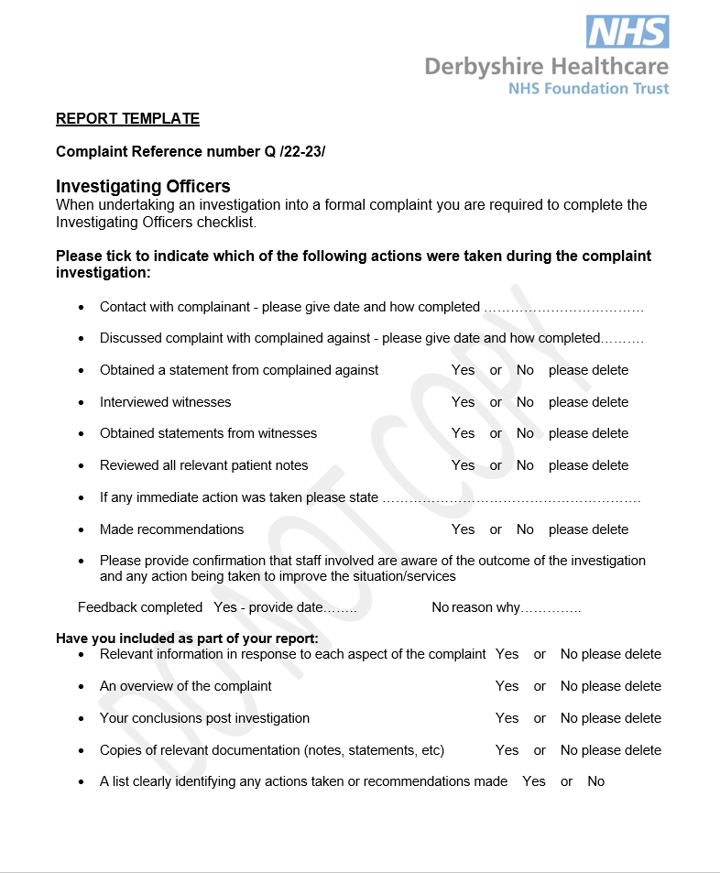

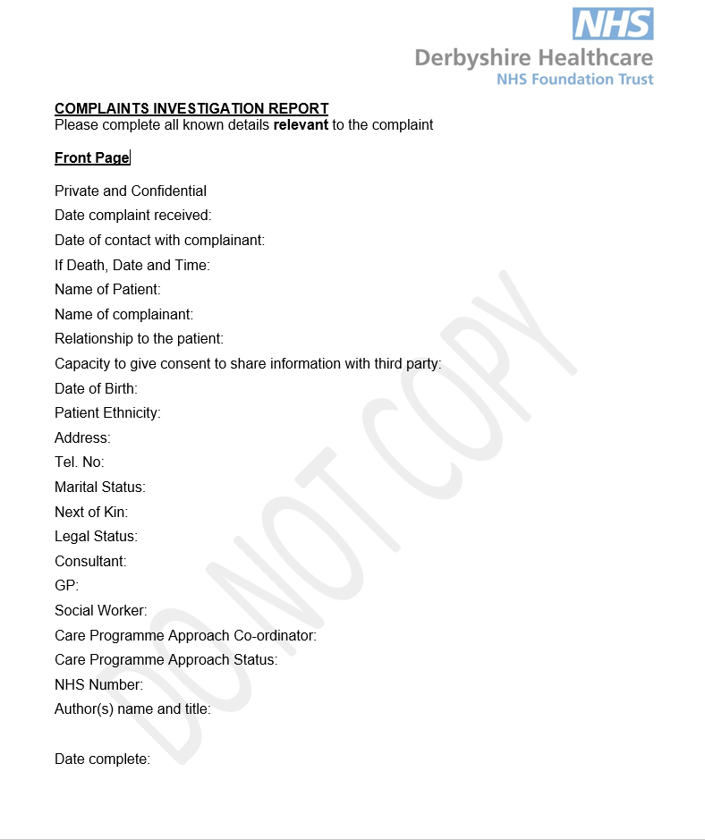

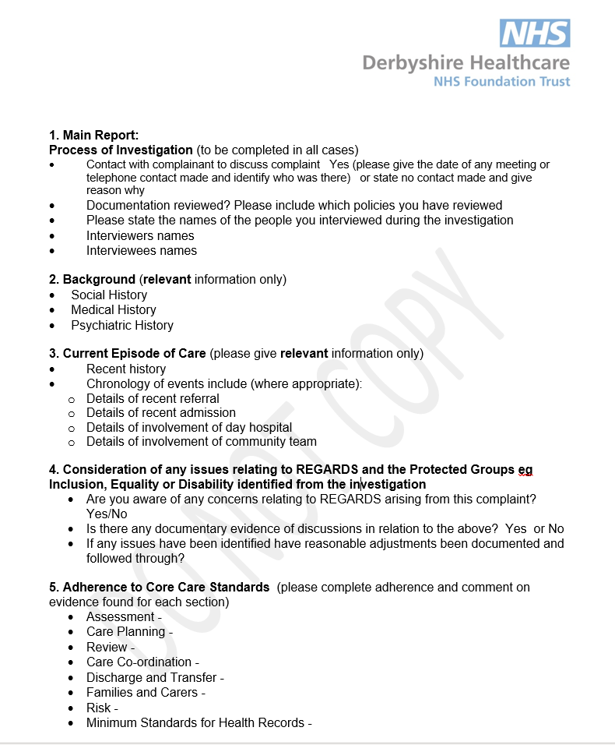

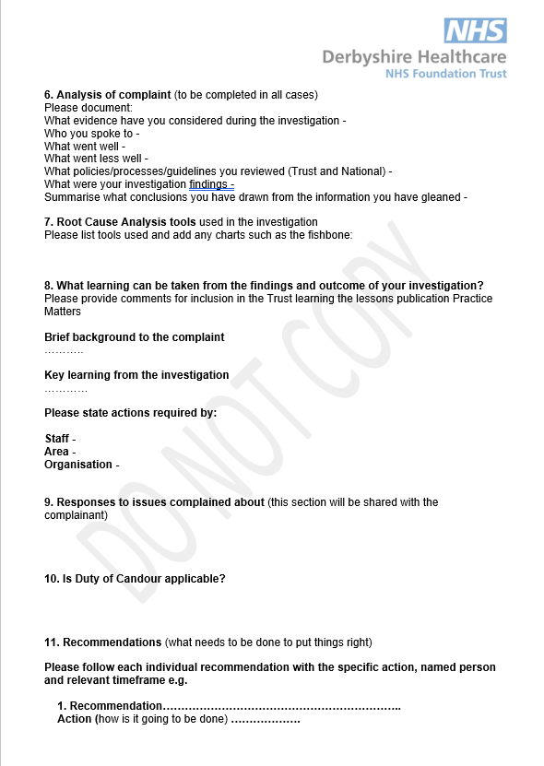

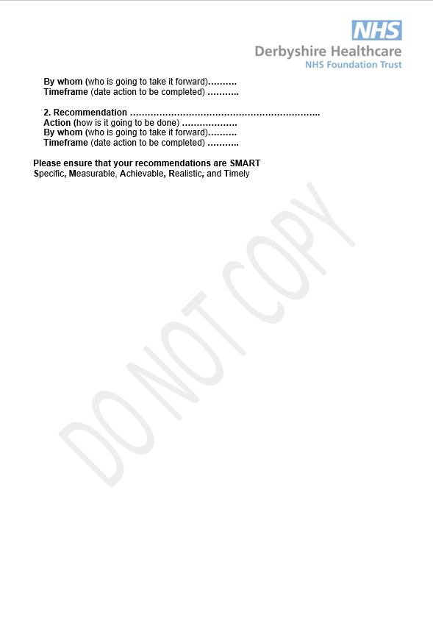

Complaints Explanation Template (for information only)

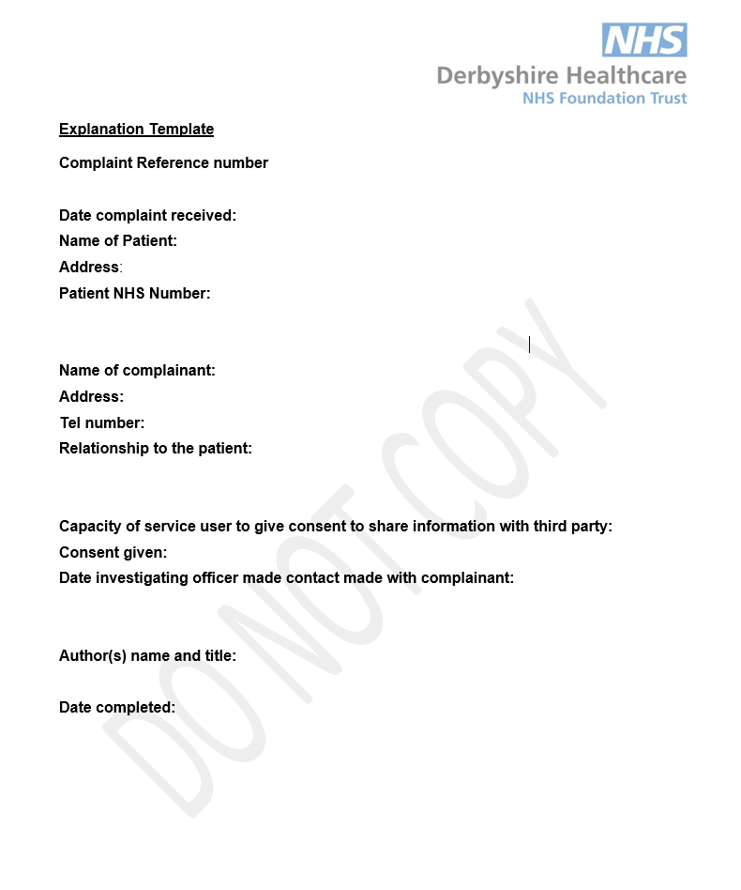

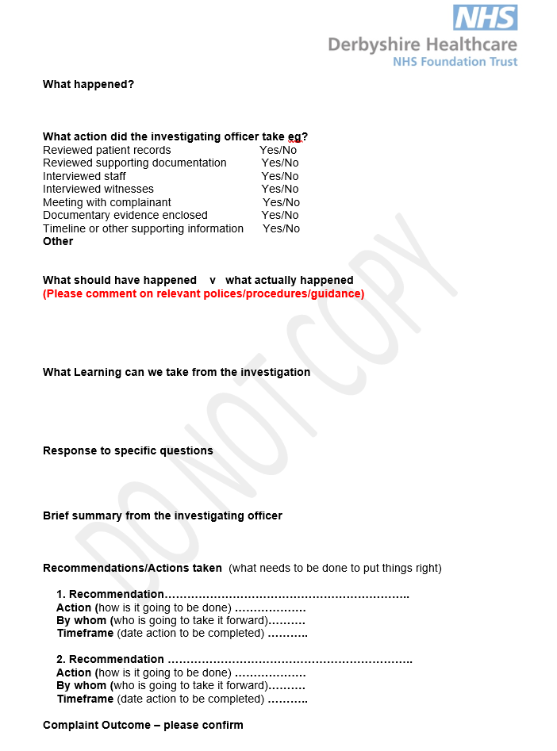

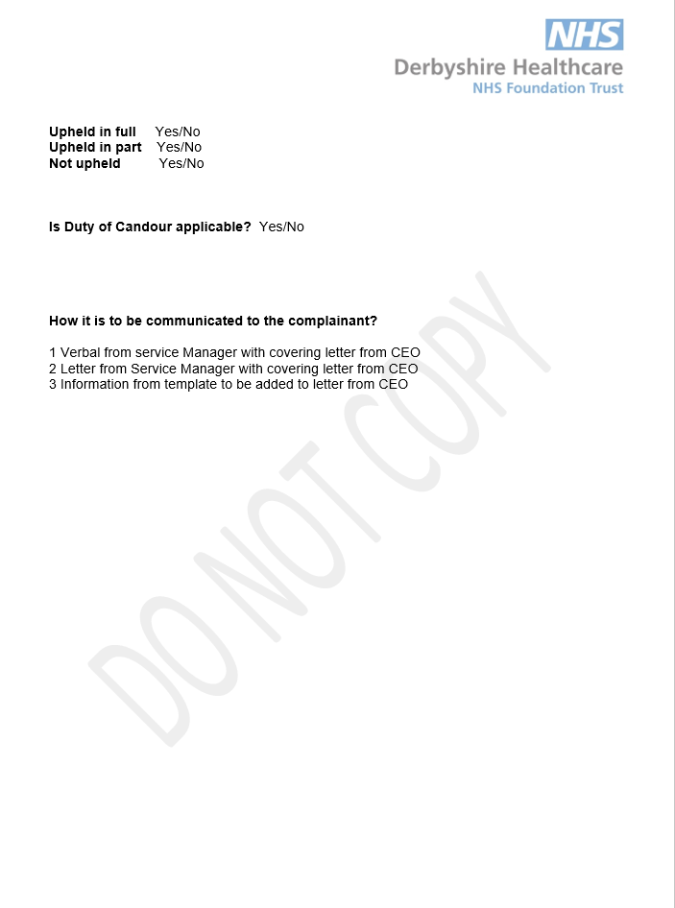

REGARDS EIRA: Assessing Equality Relevance (Stage 1)

- Name of the service / policy / project or proposal (give a brief description):

Policy and Procedure for Handling Patient Feedback 2022 - 2025:
Comments, Concerns, Complaints, and Compliments

2. Answer the questions in the table below to determine equality relevance:

 | Yes | No | Insufficient data / info to determine
Does the project / proposal affect service users, employees or the wider community, and potentially have a significant effect in terms of equality? |  | No
Is it a major project / proposal, significantly affecting how functions are delivered in terms of equality? |  | No
Will the project / proposal have a significant effect on how other organisations operate in terms of equality? |  | No
Does the decision/ proposal relate to functions that previous engagement has identified as being important to particular protected groups? |  | No
Does or could the decision / proposal affect different protected groups differently? |  | No
Does it relate to an area with known inequalities? |  | No
Does it relate to an area where equality objectives have been set by our organisation? |  | No

- On a scale of high, medium or low assess the policy in terms of equality relevance.

 | Tick below: | Notes:
High |  | If ticked all ‘Yes’ or ‘Insufficient data’
Medium |  | If ticked some ‘Yes’ and / or ‘Insufficient data’ and some ‘No’
Low | Low | If ticked all ‘No’

EIRA completed by: Complaints/Patient Experience Manager
Date: 24/2/22

